Java
Q1 | Movie Ticket Booking: Create a Movie class with movie ID, movie name, ticket price, and available seats using a parameterized constructor. Use Scanner to accept the number of tickets to book and calculate the total ticket cost after applying a discount for multiple tickets. Pass the movie ID through a command-line argument and display the booking information.
Code | import java.util.Scanner;  class Movie  {  String movieId;  String movieName;  double ticketPrice;  int availableSeats;  int ticketsToBook;  double totalCost;  Movie(String mId, String mName, double price, int seats)  {  movieId = mId;  movieName = mName;  ticketPrice = price;  availableSeats = seats;  }  void processBooking(String argMovieId)  {  if (movieId.equals(argMovieId))  {  Scanner sc = new Scanner(System.in);  System.out.print("Enter number of tickets to book: ");  ticketsToBook = sc.nextInt();  if (ticketsToBook <= availableSeats)  {  totalCost = ticketsToBook * ticketPrice;  if (ticketsToBook > 3)  {  totalCost = totalCost - (totalCost * 0.10);  }  availableSeats = availableSeats - ticketsToBook;  }  else  {  System.out.println("Not enough seats available.");  }  }  }  void display()  {  System.out.println("Movie ID: " + movieId);  System.out.println("Movie Name: " + movieName);  System.out.println("Tickets Booked: " + ticketsToBook);  System.out.println("Total Cost: " + totalCost);  System.out.println("Remaining Seats: " + availableSeats);  }  }  class MovieBooking  {  public static void main(String args[])  {  if (args.length > 0)  {  Movie m1 = new Movie("M101", "Chhello Divas", 200.0, 150);  m1.processBooking(args[0]);  m1.display();  }  }  }
Output | 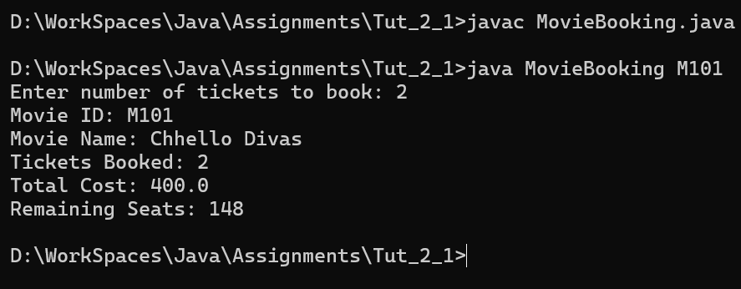
Q2 | Hospital Patient Bill: Create a Patient class with patient ID, patient name, age, and consultation fee using a parameterized constructor. Use Scanner to accept the number of days admitted, room charges per day, and medicine expenses. Calculate the total hospital bill. Pass the patient ID through a command-line argument and display the complete bill.
Code | import java.util.Scanner;  class Patient  {  String patientId;  String patientName;  int age;  double consultationFee;  int daysAdmitted;  double roomChargesPerDay;  double medicineExpenses;  double totalBill;  Patient(String pId, String pName, int pAge, double cFee)  {  patientId = pId;  patientName = pName;  age = pAge;  consultationFee = cFee;  }  void calculateBill(String argPatientId)  {  if (patientId.equals(argPatientId))  {  Scanner sc = new Scanner(System.in);  System.out.print("Enter number of days admitted: ");  daysAdmitted = sc.nextInt();  System.out.print("Enter room charges per day: ");  roomChargesPerDay = sc.nextDouble();  System.out.print("Enter medicine expenses: ");  medicineExpenses = sc.nextDouble();  totalBill = consultationFee + (daysAdmitted * roomChargesPerDay) + medicineExpenses;  }  }  void display()  {  System.out.println("Patient ID: " + patientId);  System.out.println("Patient Name: " + patientName);  System.out.println("Age: " + age);  System.out.println("Total Hospital Bill: " + totalBill);  }  }  class HospitalBilling  {  public static void main(String args[])  {  if (args.length > 0)  {  Patient p1 = new Patient("P505", "Bhavesh Patel", 45, 500.0);  p1.calculateBill(args[0]);  p1.display();  }  }  }
Output | 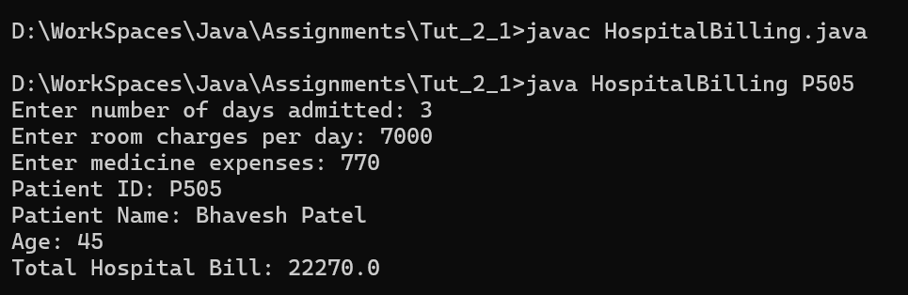
Q3 | Shopping Cart: Create a Product class with product ID, product name, price, and category using a parameterized constructor. Use Scanner to accept the quantity of different products purchased and calculate the total cart amount, discount, GST, and final payable amount. Pass the product category through a command-line argument and display the matching products.
Code | import java.util.Scanner;  class Product  {  String productId;  String productName;  double price;  String category;  int quantity;  double totalAmount;  double discount;  double gst;  double finalAmount;  Product(String pId, String pName, double pPrice, String pCategory)  {  productId = pId;  productName = pName;  price = pPrice;  category = pCategory;  }  void processCart(String argCategory)  {  if (category.equals(argCategory))  {  Scanner sc = new Scanner(System.in);  System.out.print("Enter quantity for " + productName + ": ");  quantity = sc.nextInt();  totalAmount = price * quantity;  discount = totalAmount * 0.05;  double amountAfterDiscount = totalAmount - discount;  gst = amountAfterDiscount * 0.18;  finalAmount = amountAfterDiscount + gst;  }  }  void display()  {  System.out.println("Product: " + productName);  System.out.println("Category: " + category);  System.out.println("Quantity: " + quantity);  System.out.println("Total Amount: " + totalAmount);  System.out.println("Discount (5%): " + discount);  System.out.println("GST (18%): " + gst);  System.out.println("Final Payable Amount: " + finalAmount);  }  }  class ShoppingCart  {  public static void main(String args[])  {  if (args.length > 0)  {  Product pr1 = new Product("PR001", "Khaman", 250.0, "Farsan");  pr1.processCart(args[0]);  pr1.display();  }  }  }
Output | 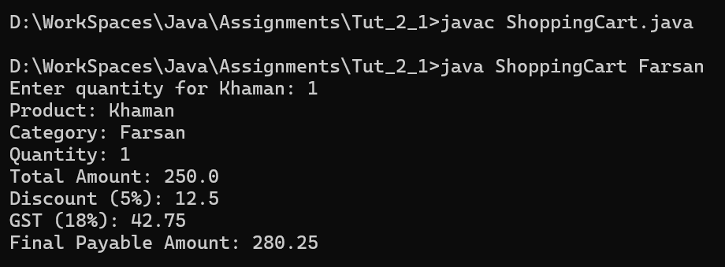
Q4 | Bus Ticket Reservation: Create a Bus class with bus number, source, destination, ticket price, and available seats using a parameterized constructor. Use Scanner to accept passenger name and number of seats required. Calculate the total ticket amount and update available seats. Pass the bus number through a command-line argument and display the reservation details.
Code | import java.util.Scanner;  class Bus  {  String busNumber;  String source;  String destination;  double ticketPrice;  int availableSeats;  String passengerName;  int seatsRequired;  double totalAmount;  Bus(String bNum, String src, String dest, double price, int seats)  {  busNumber = bNum;  source = src;  destination = dest;  ticketPrice = price;  availableSeats = seats;  }  void processReservation(String argBusNumber)  {  if (busNumber.equals(argBusNumber))  {  Scanner sc = new Scanner(System.in);  System.out.print("Enter passenger name: ");  passengerName = sc.nextLine();  System.out.print("Enter number of seats required: ");  seatsRequired = sc.nextInt();  if (seatsRequired <= availableSeats)  {  totalAmount = seatsRequired * ticketPrice;  availableSeats = availableSeats - seatsRequired;  }  else  {  System.out.println("Required seats are not available.");  }  }  }  void display()  {  System.out.println("Bus Number: " + busNumber);  System.out.println("Passenger Name: " + passengerName);  System.out.println("Route: " + source + " to " + destination);  System.out.println("Seats Booked: " + seatsRequired);  System.out.println("Total Amount: " + totalAmount);  System.out.println("Available Seats Left: " + availableSeats);  }  }  class BusReservation  {  public static void main(String args[])  {  if (args.length > 0)  {  Bus b1 = new Bus("62", "Rajkot", "Surat", 650.0, 42);  b1.processReservation(args[0]);  b1.display();  }  }  }
Output | 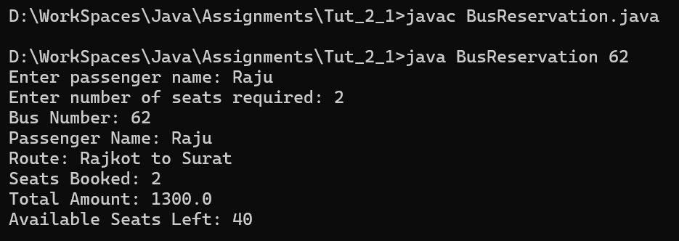
Q5 | Loan EMI Calculator: Create a Loan class with customer ID, customer name, loan amount, and interest rate using a parameterized constructor. Use Scanner to accept the loan tenure in months and calculate the monthly EMI and total repayment amount. Pass the customer ID through a command-line argument and display the complete loan details.
Code | import java.util.Scanner;  class Loan  {  String customerId;  String customerName;  double loanAmount;  double interestRate;  int tenureMonths;  double emi;  double totalRepayment;  Loan(String cId, String cName, double amount, double rate)  {  customerId = cId;  customerName = cName;  loanAmount = amount;  interestRate = rate;  }  void calculateEMI(String argCustomerId)  {  if (customerId.equals(argCustomerId))  {  Scanner sc = new Scanner(System.in);  System.out.print("Enter loan tenure in months: ");  tenureMonths = sc.nextInt();  double r = interestRate / (12 * 100);  emi = (loanAmount * r * Math.pow(1 + r, tenureMonths)) / (Math.pow(1 + r, tenureMonths) - 1);  totalRepayment = emi * tenureMonths;  }  }  void display()  {  System.out.println("Customer ID: " + customerId);  System.out.println("Customer Name: " + customerName);  System.out.println("Loan Amount: " + loanAmount);  System.out.println("Interest Rate: " + interestRate);  System.out.println("Tenure (Months): " + tenureMonths);  System.out.println("Monthly EMI: " + emi);  System.out.println("Total Repayment Amount: " + totalRepayment);  }  }  class LoanCalculator  {  public static void main(String args[])  {  if (args.length > 0)  {  Loan l1 = new Loan("90", "Jignesh Desai", 500000.0, 9.5);  l1.calculateEMI(args[0]);  l1.display();  }  }  }
Output | 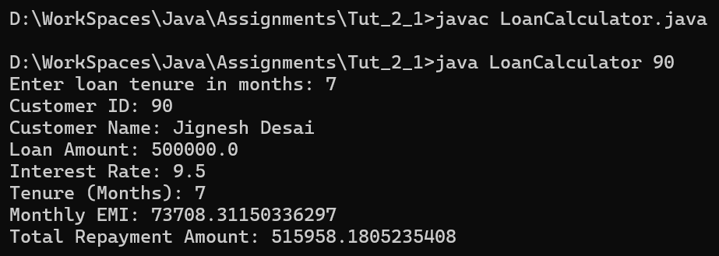
Q6 | Parking Fee Management: Create a Vehicle class with vehicle number, owner name, vehicle type, and parking rate using a parameterized constructor. Use Scanner to accept the number of hours the vehicle was parked and calculate the parking fee according to the vehicle type and parking duration. Pass the vehicle number through a command-line argument and display the parking receipt.
Code | import java.util.Scanner;  class Vehicle  {  String vehicleNumber;  String ownerName;  String vehicleType;  double parkingRate;  int hoursParked;  double parkingFee;  Vehicle(String vNum, String oName, String vType, double rate)  {  vehicleNumber = vNum;  ownerName = oName;  vehicleType = vType;  parkingRate = rate;  }  void calculateFee(String argVehicleNumber)  {  if (vehicleNumber.equals(argVehicleNumber))  {  Scanner sc = new Scanner(System.in);  System.out.print("Enter hours parked: ");  hoursParked = sc.nextInt();  if (vehicleType.equalsIgnoreCase("Car"))  {  parkingFee = hoursParked * parkingRate * 1.5;  }  else if (vehicleType.equalsIgnoreCase("Bike"))  {  parkingFee = hoursParked * parkingRate;  }  else  {  parkingFee = hoursParked * parkingRate * 2.0;  }  }  }  void display()  {  System.out.println("Vehicle Number: " + vehicleNumber);  System.out.println("Owner Name: " + ownerName);  System.out.println("Vehicle Type: " + vehicleType);  System.out.println("Hours Parked: " + hoursParked);  System.out.println("Total Parking Fee: " + parkingFee);  }  }  class ParkingManagement  {  public static void main(String args[])  {  if (args.length > 0)  {  Vehicle v1 = new Vehicle("6772", "Chetan Chauhan", "Car", 20.0);  v1.calculateFee(args[0]);  v1.display();  }  }  }
Output | 